EXPERIMENT NO: 1

Generation and Detection
Of
AM Signal, DSB-SC, SSB-SC

Name – Siddarth Awasthi
Roll- 1804609
ETC – 9
CE LAB



School of Electronics Engineering
Kalinga Institute of Industrial Technology (KIIT)
Bhubaneswar-751024
Odisha, India

AIM OF THE EXPERIMENT:

Obtaining waveforms for the following processes,
1. Generation and Detection of Amplitude modulation technique and simulation.
2. Generation and simulation of DSB-SC and SSB-SC modulation.
SOFTWARE REQUIRED = MATLAB

THEORY-

Types of Modulations-

If this value is less than 1, i.e., the modulation index is 0.5, then the modulated output would look like the following figure. It is called as Under-modulation. Such a wave is called as an under-modulated wave.

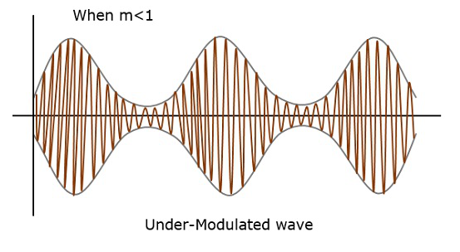

If the value of the modulation index is greater than 1, i.e., 1.5 or so, then the wave will be an over-modulated wave. It would look like the following figure.
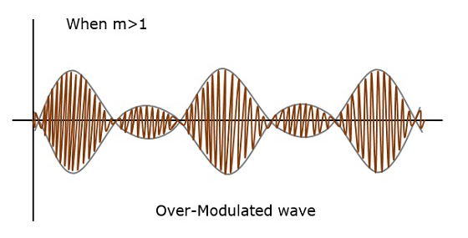

Modulation is the process of varying one or more properties of a periodic waveform, called the carrier signal, with a modulating signal that typically contains information to be transmitted.

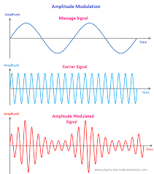

Demodulation is extracting the original information-bearing signal from a carrier wave. A demodulator is an electronic circuit (or computer program in a software-defined radio) that is used to recover the information content from the modulated carrier wave

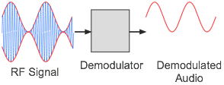

A) Amplitude Modulation (AM)-
Amplitude Modulation is defined as a process in which the amplitude of the carrier wave c(t) is varied linearly with the instantaneous amplitude of the message signal m(t).

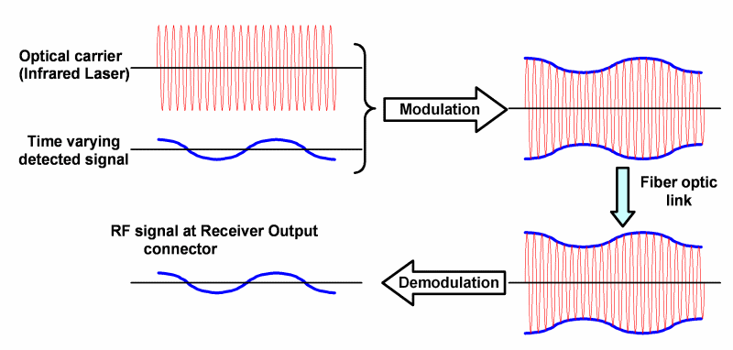
Amplitude modulation and demodulation process

- DSB-SC modulation and demodulation-
The transmission of a signal, which contains a carrier along with two sidebands can be termed as Double Sideband Full Carrier system or simply DSBFC
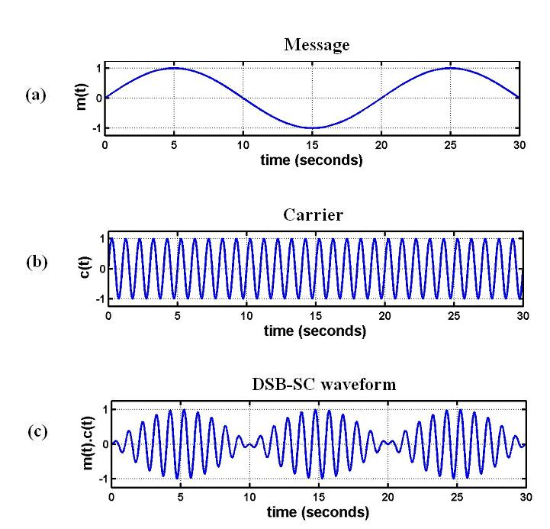

Balanced modulator is used for generating DSB-SC signal. A balanced modulator consists of two standard amplitude modulators arranged in a balanced configuration to suppress the carrier wave. The two modulators are identical except the reversal of sign of the modulating signal applied to them.

- SSB-SC Modulation and demodulation-

The DSBSC modulated signal has two sidebands. The process of suppressing one of the sidebands along with the carrier and transmitting a single sideband is called as Single Sideband Suppressed Carrier system or simply SSBSC.
The full AM (DSB AM) and DSB-SC forms of modulation are wasteful of bandwidth because they both require a transmission bandwidth equal to twice the message bandwidth. In either case, one-half the transmission bandwidth is occupied by the upper side band of the modulated wave, whereas the other half is occupied by the lower side band. The upper and lower side bands are uniquely related to each other by virtue of their symmetry about the carrier frequency. Therefore as far as the transmission of information is concerned, only one side band is necessary, and if both the carrier and the other side band are suppressed at the transmitter, no information is lost. In this way the channel needs to provide only the message bandwidth. SSB-SC signal can be generated by filter method and phase shift method.

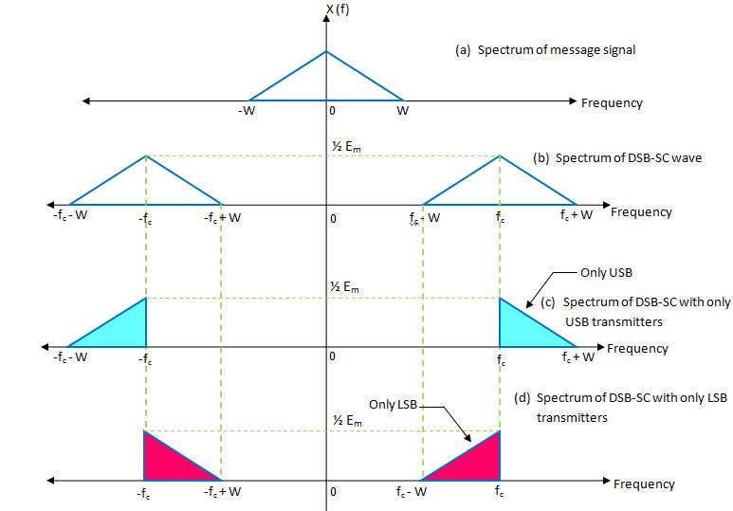

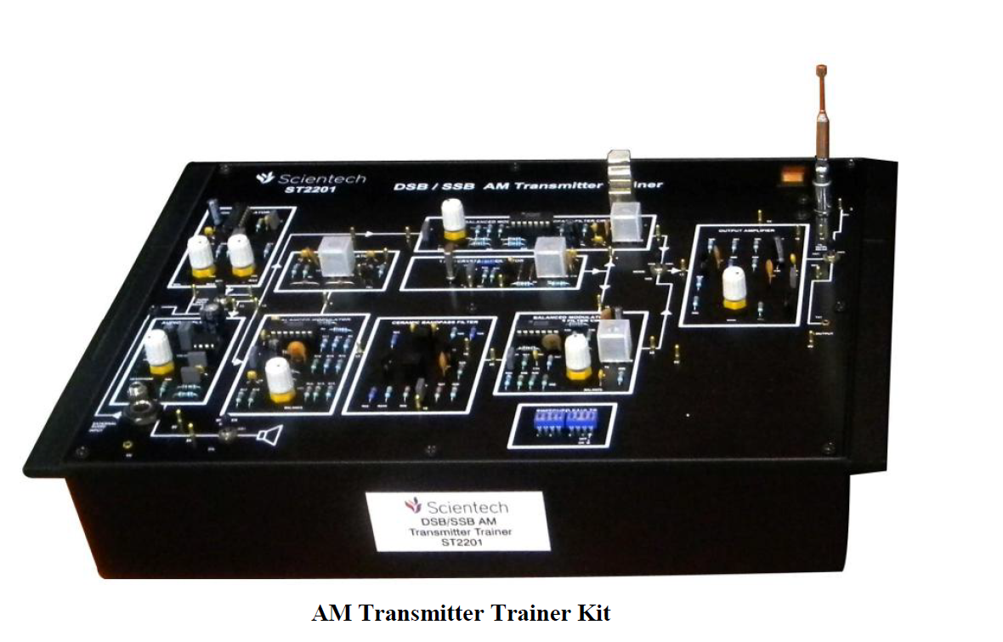
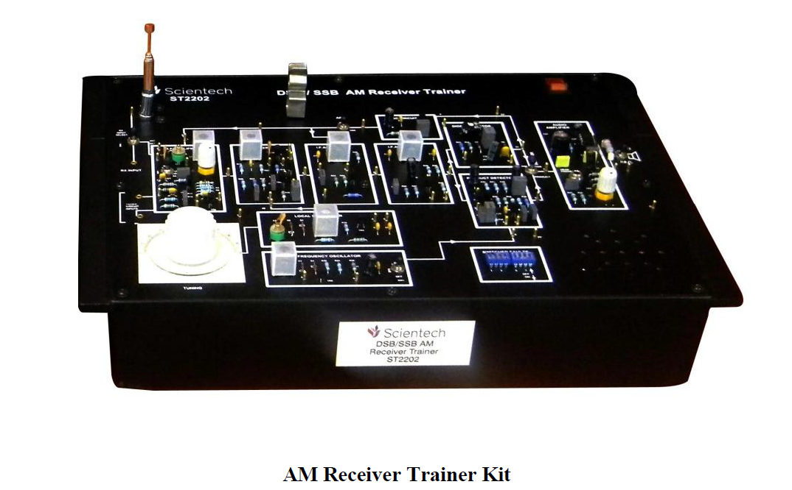

PROGRAM CODES –

- Types of modulations-

Message Signal:

clc
clear all
close all
fs=500;
t=0:1/fs:1;
fm=10;A=2;
a=A*sin(2*pi*fm*t);
subplot(2,1,1);
plot(t,a);
xlabel('Time');
ylabel('Amplitude');
title('Sinusoidal Signal');
legend('1804609')
subplot(2,1,2);
stem(t,a);
xlabel('Time');
ylabel('Amplitude');
title('Simusoidal sampled signal')
legend('1804609')

Simulation of Message Signal:
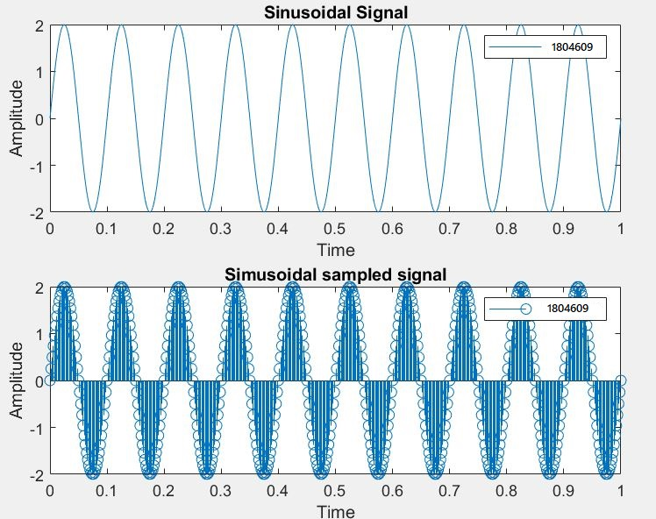

AM Modulation and Demodulation:
clc,
clear all;
close all;
t=[0:0.001:2];
f1=5;
m=sin(2*pi*f1*t);
subplot(6,2,[1,2]);
plot(t,m);
title('Message');
legend('1804609')
f2=50;
c=sin(2*pi*f2*t);
subplot(6,2,[3,4]);
plot(t,c);
title('Carrier');
m1=0.5;
s1=(1+(m1*m)).*c;
legend('1804609')
subplot(6,2,[5,6]);
plot(t,s1);
title('Under Modulation');
m2=1;
s2=(1+(m2*m)).*c;
legend('1804609')
subplot(6,2,[7,8]);
plot(t,s2);
title('100% Modulation');
m3=1.5;
s3=(1+(m3*m)).*c;
legend('1804609')
subplot(6,2,[9,10]);
plot(t,s3);
title('Over Modulation');
s5=s2.*c;
[b,a]=butter(5,0.1);
s4=filter(b,a,s5);
legend('1804609')
subplot(6,2,[11,12]);
plot(t,s4);
title('Demodulation');
legend('1804609')

Simulation:
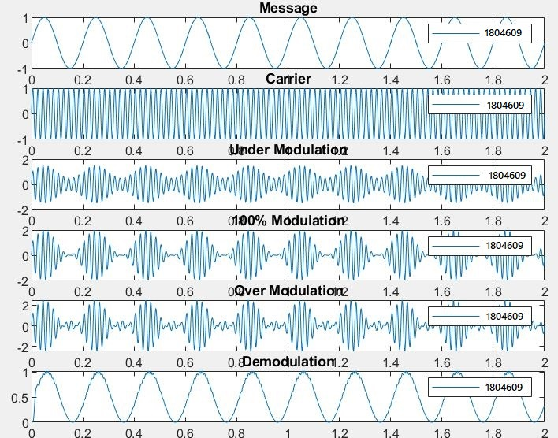

DSB-SC Modulation and Demodulation

clc;
clear all;
close all;
t=[0:0.001:1];
Am=5
f1=5;
m=Am*cos(2*pi*f1*t);
subplot(5,2,[1,2]);
plot(t,m);
title('message - 1804609');
f2=100;
Ac=6;
c1=Ac*cos(2*pi*f2*t);
subplot(5,2,[3,4]);
plot(t,c1);
title('carrier - 1804609');
f3=1000;
c2=Ac*sin(2*pi*f2*t);
M=imag(hilbert(m));
l=m.*c1;
Q=M.*c2;
Sl=0.5*(1+Q);
m1=Sl.*c1;
subplot(5,2,[5,6]);
plot(t,m1);
title('SSB-SC Lower Sideband - 1804609')
S2=0.5*(1-Q);
m2=Sl.*c1;
subplot(5,2,[7,8]);
plot(t,m2);
title('SSB-SC Upper Sideband - 1804609')
m3=Sl.*c2;
[b,a]=butter(5,0.1);
m2=filter(b,a,m3);
subplot(5,2,[9,10]);
plot(t,m2);
title('Demodulation - 1804609');

Simulation:
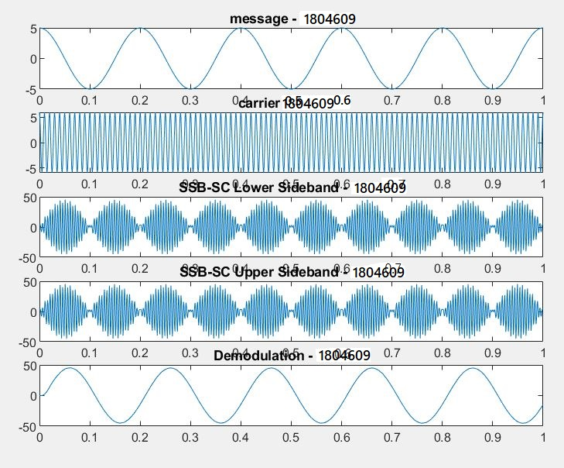

SSB-SC Modulation and Demodulation

LSB-

clc;
clear all;
close all;
%Generation of Message Signal
t=[0:0.001:2]; Am=5
f1=5; m=Am*cos(2*pi*f1*t);
subplot(6,2,[1,2]);
plot(t,m); title('message');
%Generation of Carrier Signal
f2=100; Ac=6; c1=Ac*cos(2*pi*f2*t);
legend('1804609')
subplot(6,2,[3,4]); plot(t,c1);
title('carrier');
%Generation of SSB-SC Signal
f3=1000;
c2=Ac*sin(2*pi*f2*t);
%Hilbert Transform of message signal
M=imag(hilbert(m));
l=m.*c1;
Q=M.*c2;
%SSB-SC signal considering Lower Side Band
Sl=0.5*(1+Q); m1=Sl.*c1;
legend('1804609')
subplot(6,2,[5,6]); plot(t,m1);
title('SSB-SC')
%low pass filter
m3=Sl.*c2;
[b,a]=butter(5,0.1);
m2=filter(b,a,m3);
legend('1804609')
subplot(6,2,[7,8]);
plot(t,m2); title('SSB-SC Demod');
legend('1804609')

Simulation:
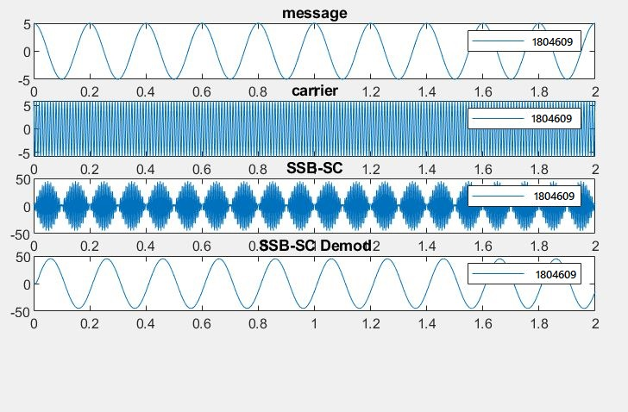

USB-

clc;
clear all;
close all;
%Generation of Message Signal
t=[0:0.001:2]; Am=5
f1=5; m=Am*cos(2*pi*f1*t);
legend('1804609')
subplot(4,1,1);
plot(t,m); title('message');
%Generation of Carrier Signal
f2=100; Ac=6; c1=Ac*cos(2*pi*f2*t);
legend('1804609')
subplot(4,1,2); plot(t,c1);
title('carrier');
%Generation of SSB-SC Signal
f3=1000;
c2=Ac*sin(2*pi*f2*t);
%Hilbert Transform of message signal
M=imag(hilbert(m));
l=m.*c1;
Q=M.*c2;
%SSB-SC signal considering Lower Side Band
Sl=0.5*(1+Q); m1=Sl.*c1;
%SSB-SC signal considering Upper Side Band
S2=0.5*(1-Q); m4=S2.*c1;
legend('1804609')
subplot(4,1,3); plot(t,m4);
title('SSB-SC USB')
%low pass filter
m3=Sl.*c2;
[b,a]=butter(5,0.1);
m2=filter(b,a,m3);
legend('1804609')
subplot(4,1,4);
plot(t,m2);
title('SSB-SC Demodulation');
legend('1804609')

Simulation-
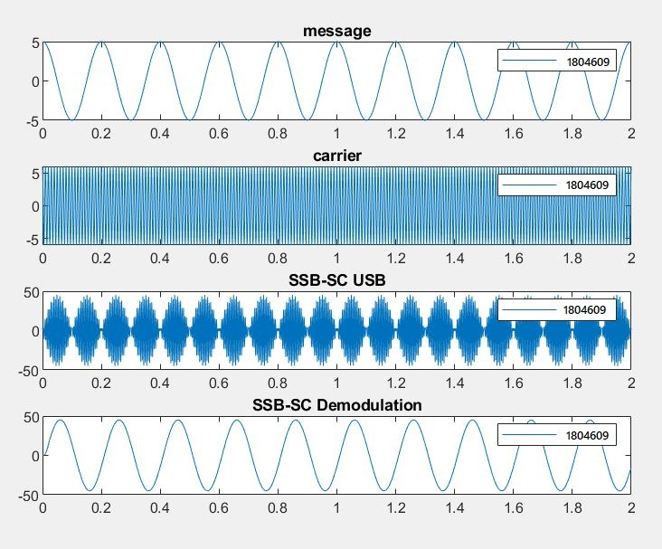

Conclusion-

In the above experiment, we have simulated the AM, DSB-SC and SSB-SC signal using MATLAB software.

Siddarth Awasthi
Roll – 1804609
ETC – 9

